BUSINESS INSIGHT REPORT
Global Sales & Financial Performance – Interactive Power BI Dashboard
Name: ____________________
Course / Subject: ____________________
Instructor: ____________________
Date: ____________________

2. Introduction
This report analyses a sales dataset through an interactive Power BI dashboard titled "Global Sales & Financial Performance". The data covers 2018 to 2024 and is organised as a star schema with Product, Customer, Employee, Geography and Date tables. In total it records about 100,000 orders and 300,006 units sold across six product categories and five regions.
- Dataset: a sales dataset of about 100K orders, 2018–2024, with sales, cost, profit and quantity measures calculated using DAX.
- Purpose of the dashboard: to monitor sales, profit, cost and volume at a glance, and to compare performance by product category, month, region and employee using interactive filters.
- Purpose of this report: to interpret what the dashboard shows, identify the key business insights and recommend actions to improve performance.

3. Dashboard Overview

Dashboard Screenshot
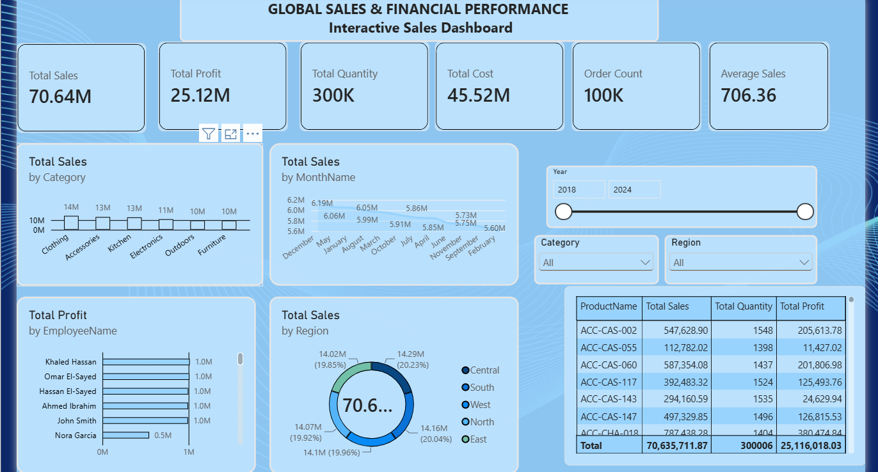
Figure 1: Interactive Sales Dashboard (no filters applied)
Purpose of the dashboard
The dashboard gives managers a single view of overall sales and profitability and lets them drill into any product category, region or year to see where performance is strong or weak.
Key components
- KPI cards: Total Sales, Total Profit, Total Quantity, Total Cost, Order Count and Average Sales
- Total Sales by Category (column chart)
- Total Sales by Month (line chart)
- Total Sales by Region (donut chart)
- Total Profit by Employee (bar chart)
- Product table showing Product Name, Total Sales, Total Quantity and Total Profit
Interactive filters available
- Year: a range slider (currently 2018 to 2024) that limits every visual to the chosen years.
- Region: a dropdown (currently "All") that filters the dashboard to Central, South, West, North or East.
- Category: a dropdown (currently "All") that filters to Clothing, Accessories, Kitchen, Electronics, Outdoors or Furniture.
The dashboard also contains a second page, "Sales performance analysis", and a "DAX Validation" page whose product table is used to check that the measures reconcile with the KPI cards (see Appendix).

4. KPI Analysis
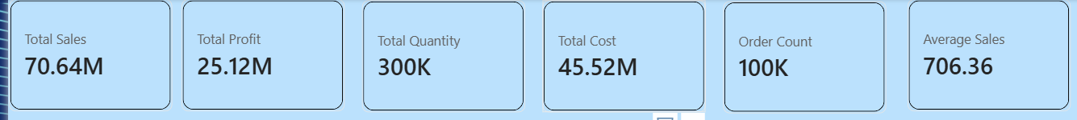
Figure 2: KPI cards
KPI | Value | Interpretation
Total Sales | 70.64M (70,635,711.87) | Overall revenue generated across 2018–2024. This is the top-line figure against which all other KPIs are judged.
Total Profit | 25.12M (25,116,018.03) | Profit is about 35.6% of sales (25.12M ÷ 70.64M), a healthy overall margin.
Total Quantity | 300K (300,006 units) | Overall volume sold. Selling about 3 units per order shows that customers typically buy several items at a time.
Total Cost | 45.52M | Costs absorb about 64.4% of sales. Cost equals Sales minus Profit (70.64M − 25.12M), so the figures reconcile.
Order Count | 100K | Indicates a very high level of order activity; sales growth depends on keeping this volume of orders flowing.
Average Sales | 706.36 | Average revenue per order (70.64M ÷ 100K). With roughly 3 units per order, the average selling price is about 235 per unit.

Overall, the business generates about 706 in sales and about 251 in profit on every order, so profitability depends on order volume and on controlling the 64% cost share.

5. Product Category Performance Analysis
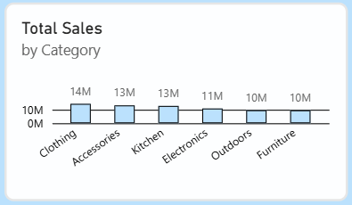
Figure 3: Total Sales by Category
Item | Observation
Highest-selling category | Clothing, at about 14M in sales (about 20% of the total).
Lowest-selling category | Outdoors and Furniture, both at about 10M (they are tied at the rounded value).
Relative differences | Clothing sells about 40% more than Outdoors or Furniture. The order is Clothing 14M, Accessories 13M, Kitchen 13M, Electronics 11M, Outdoors 10M, Furniture 10M.
Important observations | Three categories (Clothing, Accessories and Kitchen) account for roughly 40M, or about 57% of total sales. The chart shows rounded values, so small gaps between categories cannot be read exactly.

Key Insight
Sales are fairly well spread, but Clothing, Accessories and Kitchen carry the business. These three should get priority for stock and promotion, while Outdoors and Furniture need a plan to lift sales or improve margins.

6. Monthly Sales Trend Analysis
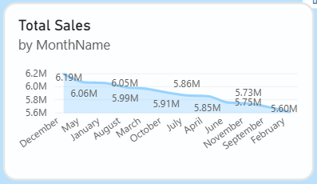
Figure 4: Total Sales by Month
Item | Observation
Highest month | December, at about 6.19M.
Lowest month | February, at about 5.60M.
Overall pattern | Sales are very stable. Every month falls between about 5.6M and 6.2M, within roughly ±5% of the monthly average of about 5.89M (70.64M ÷ 12). Months are shown in order of sales, so the line slopes downward from December to February by design.
Major fluctuations | There is no sharp spike or drop. The gap between best and worst month is about 0.59M, or about 10%. May (6.06M) and January (6.05M) are the next highest after December.

Note: the figures cover 2018–2024 combined. The vertical axis starts at 5.6M, which makes the differences between months look larger than they really are.
Key Insight
Demand is steady all year with only a mild peak in December. There is no strong seasonality, so inventory and staffing can be planned evenly, with a small increase for December.

7. Regional / Filter-Based Analysis
The dashboard uses a Region slicer, so selecting a region recalculates every KPI card, chart and table for that region. The donut chart below shows how total sales are shared across the five regions.
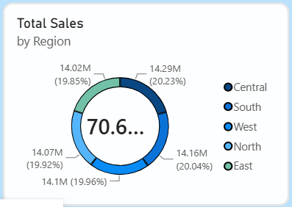
Figure 5: Total Sales by Region
Region | Major Observation | Business Insight
Central | Highest sales: 14.29M (20.23% of total). | Slightly the strongest region, but only marginally ahead of the others.
South | 14.16M (20.04%). | A strong, stable contributor to total sales.
West | 14.10M (19.96%). | Performs at the national average level of about 20%.
North | 14.07M (19.92%). | Almost identical to West; no sign of under-performance.
East | Lowest sales: 14.02M (19.85%). | Only 0.27M (about 1.9%) behind Central, so there is little room to call it weak.

Effect of the filters
- KPI changes: each region contributes about one-fifth of sales, so when a region is selected the KPI cards fall to roughly 20% of the totals.
- Category changes: the category chart shows that region's own category mix, which shows where it over- or under-sells compared with the national picture.
- Monthly and employee changes: the monthly line and the employee bars recalculate for the selected region, showing local seasonality and which employees drive that region.
Screenshots of the dashboard with each individual region selected were not available when this report was written, so the filtered KPI values are described rather than quoted.
Key Insight
Sales are almost perfectly balanced across the five regions (the gap between best and worst is under 2%). The business is not dependent on any single region, so growth is more likely to come from improving category mix and margins inside each region than from shifting focus between regions.

8. Employee Performance Analysis
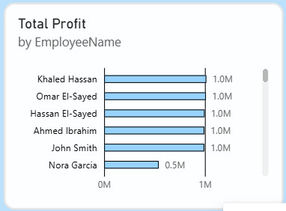
Figure 6: Total Profit by Employee
Item | Observation
Highest-performing employee | Khaled Hassan, at about 1.0M in profit. Omar El-Sayed, Hassan El-Sayed, Ahmed Ibrahim and John Smith are at the same level (about 1.0M each).
Lowest-performing employee | Nora Garcia, at about 0.5M, is the lowest among the employees visible in the chart. The chart has a scroll bar, so further employees may sit below.
Difference between employees | Nora Garcia generates about half the profit of the top group (0.5M vs 1.0M), a gap of about 0.5M.
Changes after applying filters | Choosing a Year, Region or Category recalculates the bars for that selection, so the ranking can change; this shows where individual employees perform best.

Key Insight
Five employees deliver almost identical profit of about 1.0M each, which shows a consistent top tier. Nora Garcia delivers about half, so there is a clear opportunity for coaching, territory or product-mix changes to bring lower performers up to the top group.

9. Business Insights
Observation = what the data shows. Insight = what the observation means for the business.
Insight 1: Strong, consistent profitability
Observation: profit is 25.12M on 70.64M of sales, a margin of about 35.6%, and costs are about 64.4% of sales. Insight: the business is healthy, but every one-point reduction in cost ratio would add about 0.7M of profit, so cost control is the most direct way to increase profit.
Insight 2: Balanced across regions and months, concentrated in a few categories
Observation: regions are all within about 20% ± 0.2% of sales, months are within about ±5% of average, but Clothing, Accessories and Kitchen make up about 57% of sales. Insight: the business is stable and low-risk from a location and seasonal point of view, and the main concentration risk sits in a small number of categories.
Insight 3: Product margins vary widely even though volumes are similar
Observation: in the product table, units sold are very similar (about 1,390 to 1,555 per product) but profit margins differ greatly. For example ACC-HEA-092 earns about 52% (433,505 profit on 834,341 sales), while ACC-CAS-055 earns only about 10% (11,427 on 112,782). Insight: product mix and pricing, rather than volume, drive profit, so promoting high-margin products and reviewing low-margin ones would raise profit without needing more sales.

10. Business Recommendations
- Product category planning: Prioritise stock and promotions for Clothing, Accessories and Kitchen, and set growth targets for Outdoors and Furniture (for example bundles, seasonal campaigns or range reviews).
- Inventory planning: Plan stock evenly through the year, with a modest increase ahead of December (the peak at about 6.19M) and no heavy build-up needed for the quieter months such as February.
- Regional strategy: Because all five regions contribute about 20% each, keep a balanced approach and use the Region slicer to find regional category gaps instead of moving resources between regions.
- Employee performance: Use the top group (about 1.0M profit each) as a benchmark, share their practices and give targeted coaching or support to lower performers such as Nora Garcia (about 0.5M).
- Margin and product management: Review products with low margins (such as ACC-CAS-055 at about 10%) for price increases or cost reduction, and promote high-margin products (such as ACC-HEA-092 at about 52%).
- Customer targeting: With an average order value of about 706 and about 3 units per order, offer bundles and volume incentives to raise the average order value.

11. Conclusion
- Overall dashboard findings: the business generated 70.64M in sales and 25.12M in profit (about 35.6% margin) from 100K orders and 300K units, with results spread evenly across five regions and twelve months.
- Most important business insight: profit is driven by product mix and margin differences, not by volume, because units sold per product are similar but margins range from about 10% to 52%.
- Key recommendation: focus on margin improvement and on the three leading categories, while lifting the lower-performing employees and categories.
- How Power BI helped: interactive slicers, cross-filtering visuals and DAX measures (Total Sales, Total Profit, Total Cost, Order Count and Average Sales) made it possible to explore sales by year, region and category quickly and to confirm that all figures reconcile.

Appendix: Data Validation
The "DAX Validation" page lists sales, quantity and profit by product. Its grand totals (70,635,711.87 in sales, 300,006 units and 25,116,018.03 in profit) match the KPI cards on the dashboard, confirming that the DAX measures are consistent.
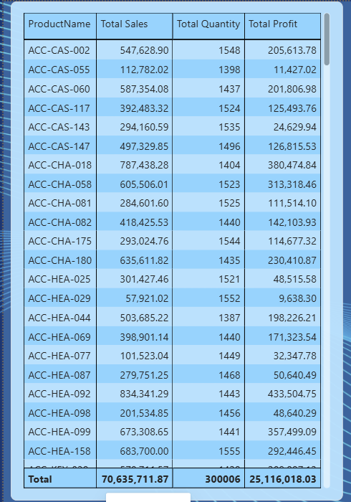
Figure 7: DAX Validation page

